FORM 2
THE PATENTS ACT,
1970 (39 of 1970)
&
THE PATENTS RULES, 2003
COMPLETE SPECIFICATION
(See Section 10; rule 13)
TITLE OF THE INVENTION
SMART WATER FLOWING CONTROL SYSTEM
APPLICANTS
S.NO | NAME | ADDRESS
 | Dr. K.SIVANADAM | Assistant Professor,  Department of ECE,  M. Kumarasamy College of Engineering,  Karur, India-639113
 | R.B.HARSHAVARTHINI | UG Students,  Department of ECE,  M. Kumarasamy College of Engineering Karur, India-639113
 | S.HARSHINI
 | A.KIRUBASAKTHI
 | K.MADHUMITHA

The following specification particularly describes the invention and the manner in which it is to be performed. The accompanying drawings, which are included in and form a part of the specification, illustrate an incarnation of the present invention and together with the description, serve to explain the principles of the invention.

Title
SMART WATER FLOWING CONTROL SYSTEM
Field
1. Sensor Integration : Sensors capable of accurately measuring the density and flow levels of water. These sensors should provide real-time data to the control system.
2. Control System : Develop a control system that processes the sensor data and determines the optimal water flow rate based on predefined parameters and algorithms. This system should be capable of wireless communication to facilitate remote control.
3. Flow Display : Utilize a software application to visually present the current water flow rate. This display should be easily readable and provide real-time updates.
4. Data Storage : Implement a data storage mechanism using a wi-fi module. This allows the system to store the flow data in a local server or drive without relying on external cloud services. Ensure data security and integrity during storage.
5. User Interface : Create a user-friendly interface to enable users to monitor and to control the system status, adjust settings if necessary, and access historical flow data stored in the wi-fi module.
6. Safety Features : Incorporate safety features such as emergency shut-off mechanisms or alarms in case of sensor malfunctions or abnormal system behavior.
By integrating these components, the smart water flowing control system can effectively manage water flow based on flow of water conditions, display relevant information, and securely store flow data using wi-fi module connectivity in software application.

Background of the Invention
This system is developed to address the need for efficient water flow control and to monitor in society processes involving apartments and householdings. By integrating flow sensors with wireless technology and wi-fi module to storage capabilities, the system aims to optimize water usage, enhance production quality, and streamline data management without external dependencies on cloud services.

Objects of the invention
The primary objective of this invention is to provide an efficient and automated solution for controlling water flow in society processes involving apartments and householdings. By leveraging advanced sensing technology, wireless communication, and software-based data storage, the invention aims to optimize water usage, enhance production efficiency, and facilitate data management without reliance on external cloud services.

Summary of the Invention
The proposed invention is a wireless water flow control system designed for society processes involving apartments and householdings. It automatically adjusts water flow by analysing the flow and density levels of the materials. Key features include
- Automatic Control:
The system autonomously regulates water flow based on real-time data from flow sensors, ensuring optimal conditions for production processes.

- Visual Feedback:
A software application provides operators with a clear view of the water flow rate, facilitating monitoring and control.

- Data Storage:
Water flow data, including numerical values, is securely stored using
wi-fi module technology on a local server or software app, enhancing data security and accessibility.

- Cloud-free Operation:
The system operates independently of external service providers like cloud services, reducing dependencies and ensuring continuity of operations.

- Efficiency and Cost Savings:
By optimizing water usage and minimizing waste, the system promotes efficiency and cost savings in society operations.

- Environmental Impact:
Efficient water management contributes to environmental sustainability by reducing water consumption and promoting responsible resource usage.

Overall, the smart water flowing control system offers a comprehensive solution for managing water flow in society settings, combining automation, data management, and environmental responsibility.

Novelty
1. Blynk application:
Blynk application is a platform that enables the management of connected devices via smartphones. This application supports automation tasks and scheduling, enabling users to automate device actions, it also includes features for sending notifications via email, SMS or push notifications. In our project smart water flowing control system this application is used to display the flow of water which is measured in the flow sensor and it is also used to controls the operation of solenoid valve if the maximum limitation of water is reached. It also gives the alert message if the excess water is used.

2. Measuring and Controlling
In our smart water flowing control system the flow sensor which is used to measure the flow of water and the solenoid valve which is used for controlling operation both on and off are combined as one product .In the flow sensor it measures the flow of water and fed it to application by using the Arduino and the wi-fi module, we can see the flow of water and used to On and off the solenoid valve through the application. By combining the flow sensor and the solenoid valve into a single product in this project we can able to reduce the consumption of space required for both the flow sensor and the solenoid valve.
3. Water meters
Water meters in apartments are used to measure the water consumption of individual units within building. Unlike water meters this smart water flowing control system is used to measure the flow of water ,displays the flow of water in the blynk application wherever we are, and this system also used to control the operations of water through solenoid valve . So this system is considered as one of the best replacement for this water meters in some apartments with more advantages in our society.

Brief Description of the Drawings
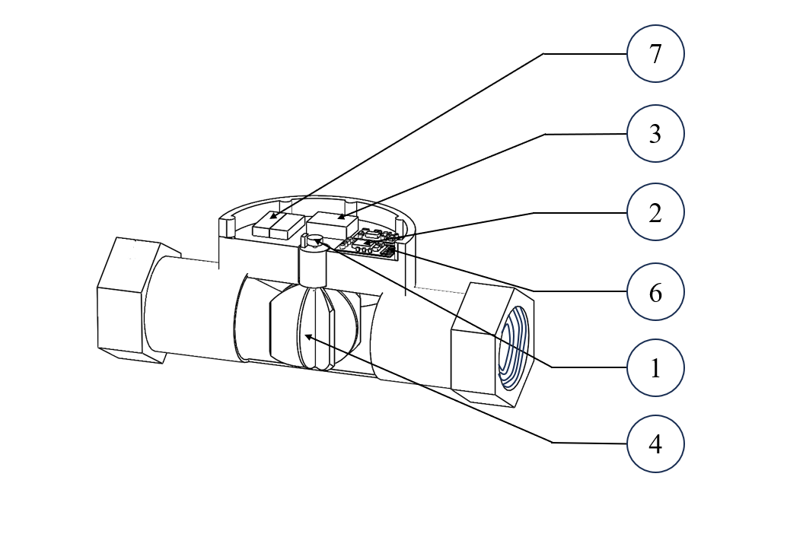
Diagram Description:
The diagram for the smart water flowing control system can include the following components and their connections:
1. Flow Sensors: These sensors are placed in the vicinity of water and pipes to measure the flow of water levels.
2. ESP 8266 WI-FI Module: This module receives data from the sensors and sends commands to control the water flow.
3. Control Unit: The control unit processes the data received from sensors and sends commands to adjust the water flow accordingly.
4. Water Flow Control Valve: This valve regulates the flow of water based on commands received from the control unit.
5. Software application: The software app displays the water flow rate in real-time, providing visual feedback to operators.
6. WI-FI Module: The wi-fi module enables data storage on a local server or drive without using external cloud services.
The diagram should clearly illustrate the flow of data and control signals between these components, showing how the system monitors water flow levels, adjusts water flow, displays flow rate, and stores data using wi-fi module.

Detailed Description of the Invention
1. Sensing Mechanism:
The system is equipped with flow sensors strategically placed to observe flow of water continuously.
2. Data Analysis and Control:
Data from sensors are processed by the control unit to determine the optimal water flow rate required based on the water flow levels.
3. Water Flow Adjustment:
A water flow control valve is integrated into the system, allowing for precise adjustment of water flow according to the commands received from the control unit.
4. Display Unit:
The system includes a software application that shows real-time information about the water flow rate and water level, providing visual feedback to operators.
5.SOFTWARE APPLICATION:
The Software application is used to control and manage the overflow and the wastage of water by the flow of water displaying in this software and also used to monitor the flow rate of water.
6.WI-FI MODULE:
A wi-fi module is established to enable the storage of water flow data on a local server or drive securely.
7. Autonomous Operation:
The system operates autonomously, continuously monitoring and adjusting water flow based on real-time data, without the need for manual intervention.
8. Security Measures:
The ESP 8266-based data storage system is designed with robust security measures to protect the stored data from unauthorized access or breaches.

9. Scalability and Compatibility:
The system is designed to be scalable and compatible with existing industrial setups, allowing for seamless integration and expansion as needed.
10. Environmental Impact:
By efficiently controlling water flow based on flow and usage levels, the system contributes to reducing water wastage and promoting environmentally sustainable practices in society processes.

Claims
I/We Claim,
Here are some potential claims for the smart water flow control system based on the problem statement and expected solution:
1.Automated Water Flow Adjustment:
The system claims the ability to automatically adjust water flow rates based on real-time observations of flow levels in pipes and water storage tank.
2. Precision Control:
Claims precise control over water flow rates, ensuring optimal conditions for society processes.
3. Real-time Monitoring:
Claims real-time monitoring and display of water flow rates through a software application, providing operators with instant feedback.
4. Secure Data Storage:
Claims secure storage of water flow data in wi-fi module, without relying on external cloud services.
5. Data Integrity:
Claims data integrity and accessibility, ensuring that stored water flow data remains accurate and protected from unauthorized access.
6.Cost Efficiency:
Claims cost efficiency by utilizing wi-fi module based storage and avoiding the need for external service providers like cloud services, reducing operational costs.
7. Environmental Impact:
Claims environmental benefits by optimizing water usage based on overflow and wastage levels, contributing to sustainable resource management.
8.Compatibility:
Claims compatibility with existing society setups, offering seamless integration and scalability as per operational requirements.

Signature of Applicants:

K.SIVANADAM | HARSHAVARTHINI.R.B | HARSHINI.S | KIRUBASAKTHI.A | MADHUMITHA.K

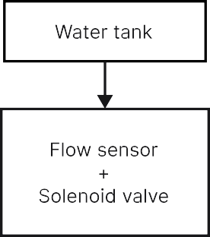
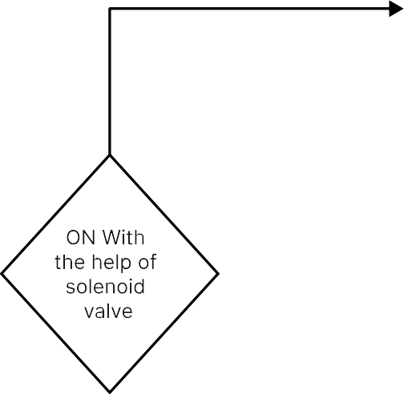
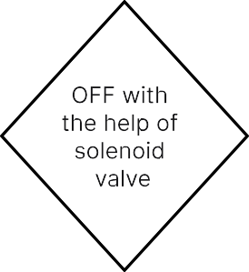
FLOW DIAGRAM
NO
YES
100>n
n=Quantity of water
Blink Application

Abstract

- Introducing a smart water flowing control system is used to control the wastage of water based on the overflowing and monitoring the level of flow of water.
- Highlighting the importance of smart water flowing control in the society is
to achieve efficiency and quality.
- Describe the flow control mechanism that it adjust the flow of water according to monitoring the real-time flow of water and usage in households or in society.
- Discuss the usage of blink application is to visually represent the flowrate of water and to control the flow of water.
- Highlight the use of a wi-fi module for storing water flow data.
- Outline the advantages of this system, is that to control the overflow of water, wastage of water, water sufficiency and increased operational efficiency.
- Emphasize the environmental benefits of water flow control, contributing to sustainable household and also for Society based practices.

